**API RESPONSE:**

{

"code": "SUCCESS",  
 "error": null,  
 "transactionResponse": {  
 "orderId": 966004837,  
 "transactionId": "09c512e6-f018-4250-8009-f4f94747d321",  
 "state": "PENDING",  
 "paymentNetworkResponseCode": null,  
 "paymentNetworkResponseErrorMessage": null,  
 "trazabilityCode": null,  
 "authorizationCode": null,  
 "pendingReason": "AWAITING_NOTIFICATION",  
 "responseCode": "PENDING_TRANSACTION_CONFIRMATION",  
 "errorCode": null,  
 "responseMessage": null,  
 "transactionDate": null,  
 "transactionTime": null,  
 "operationDate": null,  
 "referenceQuestionnaire": null,  
 "extraParameters": {  
 "EXPIRATION_DATE": 1504069199000,  
 "URL_PAYMENT_RECEIPT_PDF": "https://checkout.payulatam.com/ppp-web-gateway-payu/receipt?vid=966004837Y09c512e6f018425Yf98b65302ccf9a4",  
 "BANCOLOMBIA_SERVICE_CODE": "27141",  
 "REFERENCE": 966004837,  
 "BANCO_BOGOTA_SERVICE_CODE": "000018184",  
 "BANK_REFERENCED_NAME": "bank_referenced.bancolombia",  
 "BAR_CODE": "(415)7709998013377(8020)0966004837(3900)00000000010000(96)20170829", "URL_PAYMENT_RECEIPT_HTML": "https://checkout.payulatam.com/ppp-web-gateway-payu/app?vid=966004837Y09c512e6f018425Yf98b65302ccf9a4"

}  
…  
 }  
}

**EXTRAPARAMETERS DESCRIPTION**

EXPIRATION_DATE: Expiration date in Unix format  
URL_PAYMENT_RECEIPT_PDF: URL to download the receipt in pdf  
BANCOLOMBIA_SERVICE_CODE: Bancolombia agreement code  
REFERENCE: Payment reference (PayU’ order Id)  
BANCO_BOGOTA_SERVICE_CODE: Banco de Bogotá agreement code  
BANK_REFERENCED_NAME: Name of one of the banks listed  
BAR_CODE: Barcode in string  
URL_PAYMENT_RECEIPT_HTML: URL to redirect the shopper to see the voucher into the web browser

**VOUCHER IN THE WEB SITE:**

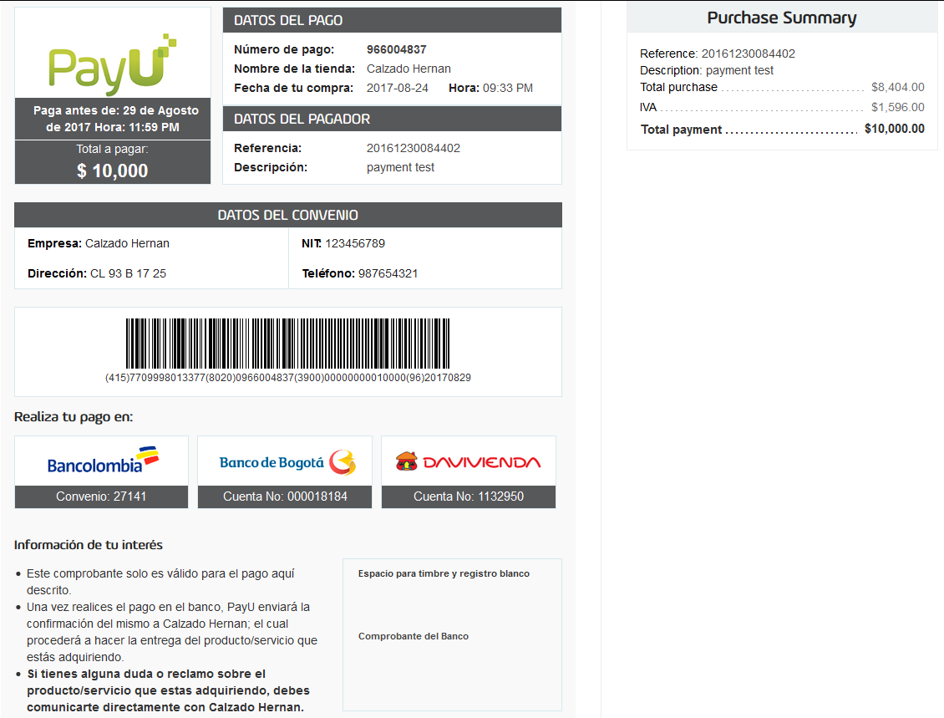

QUERY API RESPONSE:

Using the query API you will get the bank in which the shopper made the payment into result.payload.transactions.transactionResponse.extraParameters.BANK_REFERENCED_NAME. The possible values are “DAVIVIENDA”, “BANCOBOGOTA” or “BANCOLOMBIA”  
  
{  
 "code": "SUCCESS",  
 "error": null,  
 "result": {"payload": {  
 ...  
 "transactions": [ {  
 "transactionResponse": {  
 ...   
 "extraParameters": {  
 "PAYMENT_METHOD": "1",  
 "CHECKOUT_VERSION": "V2",  
 "EXTRA2": "alex-guerrero-f@hotmail.com,jhon stiven guerrero florido ,3217861994,cali,3106681866",  
 "BANK_REFERENCED_NAME": “DAVIVIENDA” or “BANCOBOGOTA” or “BANCOLOMBIA”  
 ...  
 }  
 }]

}}

}